**Skin Cancer – Dermatoscopic Image Classification**

**Using Transfer Learning**

Zeqiang Li

IS, College of Engineer

Northeastern University

Yidi Xu

IS, College of Engineer

Northeastern University

Mingguan Liu

IS, College of Engineer

Northeastern University

**Abstract**

*Skin cancer, the most common human malignancy, is primarily diagnosed visually. The HAM 10000 dataset, which contains the dermatoscopic images from different populations, acquired and stored by different modalities. This project chooses this as the topic to classify the images into diverse types of skin cancer. The data for each type of skin cell is unbalanced, this project used various image transformation methods to apply augmentation, in order to increase the diversity of each type of image without losing features, and applied transfer learning with the base model of vgg19 and resnet50 to develop a convolutional neural network model for skin cancer image classification, using Amazon EC2 P3 instances and AWS Deep Learning AMIs. The best result is of 82% accuracy.*

**Keywords**: Skin Cancer, CNN, Transfer Learning, VGGNet, ResNet

**1 Introduction**

**1.1 Background**

Skin cancer — the abnormal growth of skin cells — most often develops on skin exposed to the sun. But this common form of cancer can also occur on areas of your skin not ordinarily exposed to sunlight. It develops primarily on areas of sun-exposed skin, including the scalp, face, lips, ears, neck, chest, arms and hands, and on the legs in women. But it can also form on areas that rarely see the light of day — your palms, beneath your fingernails or toenails, and your genital area. Moreover, it affects people of all skin tones, including those with darker complexions.

Automated classification of skin lesions using images is a challenging task owing to the fine-grained variability in the appearance of skin lesions. In addition, training of neural networks for automated diagnosis of pigmented skin lesions is hampered by the small size and lack of diversity of available dataset of dermatoscopic images. In order to detect skin cancer, to use transfer learning first, which is a machine learning method where a model developed for a task is reused as the starting point for a model on a second task. Then applying deep convolutional neural networks, which could show potential for general and highly variable tasks across many fine-grained object categories. In this way, if the result is satisfactory, it can generate a model to build up strategy to detect and classify the skin cancer.

**1.2 Given Datasets**

One dataset is provided by Harvard Dataverse, and another access would be on Kaggle dataset, called Skin Cancer MNIST: HAM10000. The HAM10000 ("Human Against Machine with 10000 training images") dataset is a dataset created by Tschandl, P., Rosendahl, C. & Kittler, H. The purpose of this dataset is for training neural networks to automate diagnosis of pigmented skin lesions. The dataset contains the 10015 dermatoscopic images and metadata with 7 attributes of each image include all important diagnostic categories in the realm of pigmented lesions: Actinic keratoses and intraepithelial carcinoma / Bowen's disease (akiec), basal cell carcinoma (bcc), benign keratosis-like lesions (solar lentigines / seborrheic keratoses and lichen-planus like keratoses, bkl), dermatofibroma (df), melanoma (mel), melanocytic nevi (nv) and vascular lesions (angiomas, angiokeratomas, pyogenic granulomas and hemorrhage, vasc).

**1.3 Dataset Information**

Training of neural networks for automated diagnosis of pigmented skin lesions is hampered by the small size and lack of diversity of available dataset of dermatoscopic images. More than 50% of lesions are confirmed through histopathology (histo), the ground truth for the rest of the cases is either follow-up examination (follow_up), expert consensus (consensus), or confirmation by in-vivo confocal microscopy (confocal). The dataset includes lesions with multiple images, which can be tracked by the lesion_id-column within the HAM10000_metadata file.

Each row has the following features:

* Lesion_id: The skin lesion id
* Image_id: The image id
* Dx: lesion type, target variable
* Dx_type: the full name of dx
* Age: the population age
* Sex: the population sex
* Localization: the case localization

**2 Dataset Processing**

The HAM10000 ("Human Against Machine with 10000 training images") dataset, which collected dermatoscopic images from different populations, acquired and stored by different modalities.

First, exploring the dataset to generate the virtualization of data.

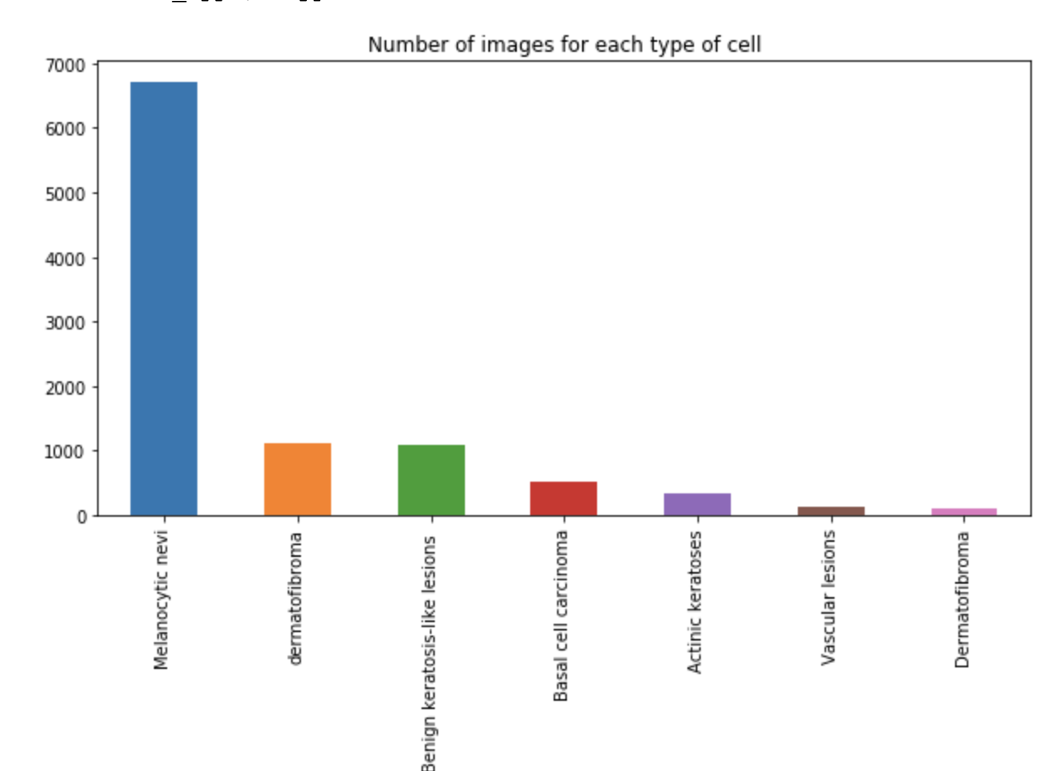

Figure

From Figure 1, it could tell that the dataset is very unbalanced. Most machine learning classification algorithms are sensitive to unbalance in the predictor classes. An unbalanced dataset will bias the prediction model towards the more common class.

**2.1 Data Augmentation**

To avoid biases, applying data augmentation for adding more images to the original dataset.

Figure 1 demonstrated that 1st type of skin cancer has large number, otherwise, the number for image of rest types are small. Therefore, applying 5 augmentation to the 2nd and 3rd type of skin cells, including

1. Transpose and center crop

2. Rotation

3. Rotation and center crop

4. Affine Transformation

5. Perspective Transformation

And applying 10 augmentation to the last four types of skin cells as following:

1. Transpose and center crop

2. Rotation

3. Rotation and center crop

4. Affine Transformation

5. Perspective Transformation

6. Flipping

7. Flipping, transpose, and add border

8. Gamma

9. Blur

10. Translation

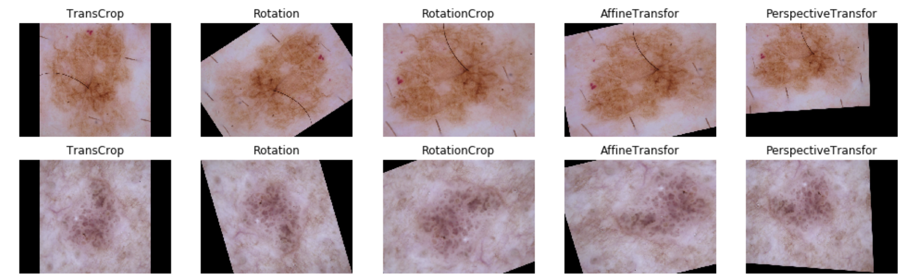

Figure

Figure 2 illustrates the sample of images after five augmentation of 2nd and 3rd type of skin cells.

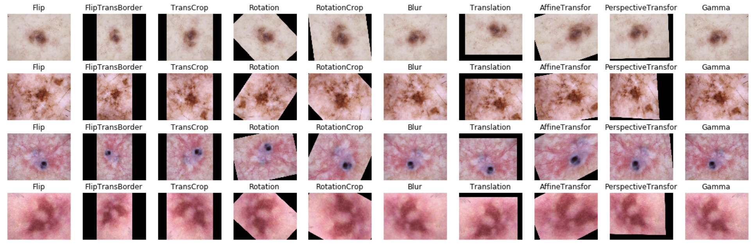

Figure

Figure 3 is the screenshot of the sample of images after ten augmentation of the last four types of skin cells.

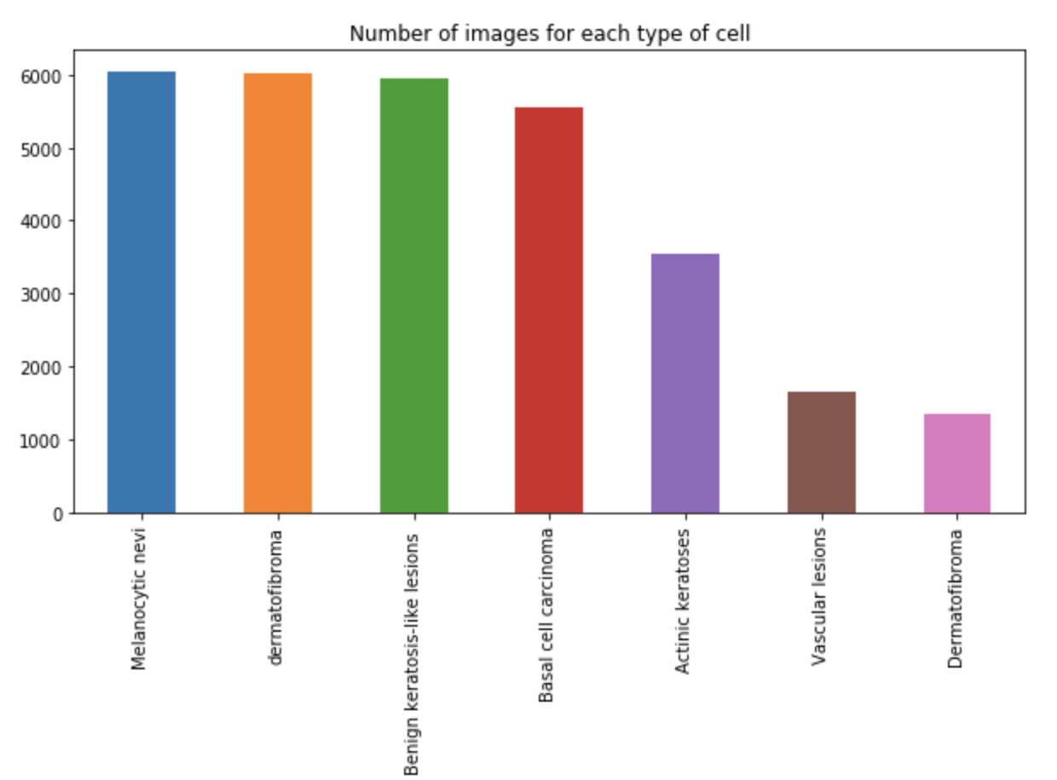

Figure

This is the plot for the distribution of number of images for each type of cell after augmentation. This figure shows that it is more balanced than the original dataset.

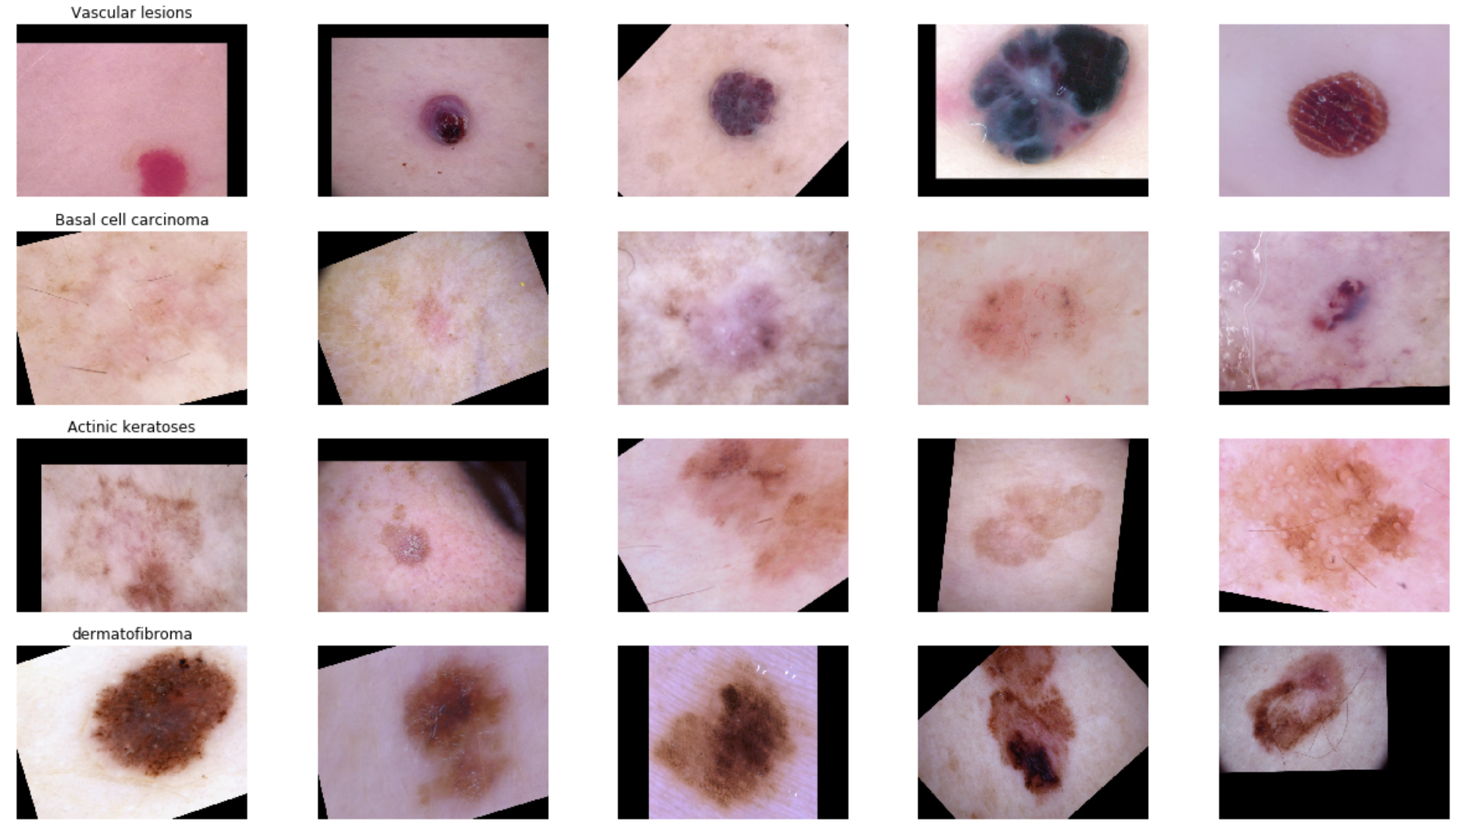

Figure

This is the new data sample after augmentation for each type of cell.

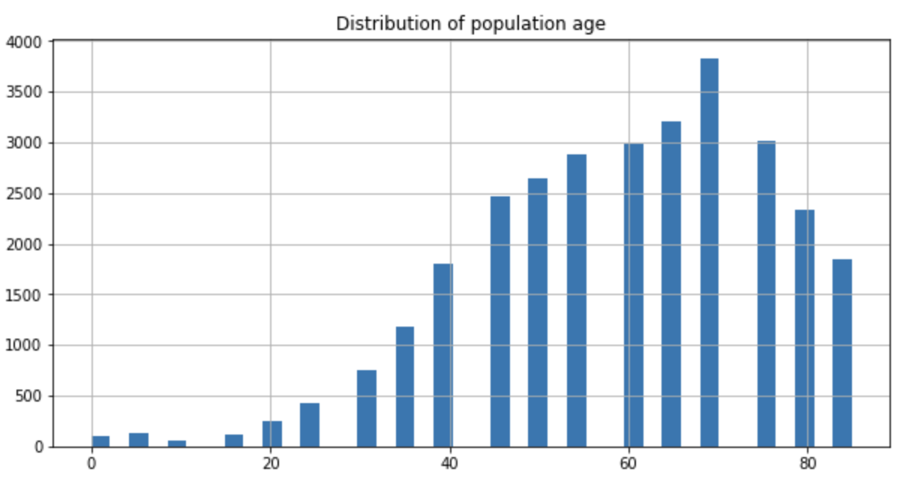

Figure

Figure 6 shows that the distribution of population age after augmentation, which is normally distributed, and centered at about age of 70, this is good news for the project to use.

In practice, very few people train an entire Convolutional Network from scratch (with random initialization), because it is relatively rare to have a dataset of sufficient size. Instead, it is common to pretrain the data, thus transfer learning could be used in such a case.

**3 Transfer Learning**

Transfer learning is a machine learning technique where a model trained on one task is re-purposed on a second related task. In Transfer Learning, the knowledge of an already trained Machine Learning model is applied to a different but related problem. It mostly used in Computer Vision and Natural Language Processing Tasks, because of the huge amount of computational power that is needed for them.

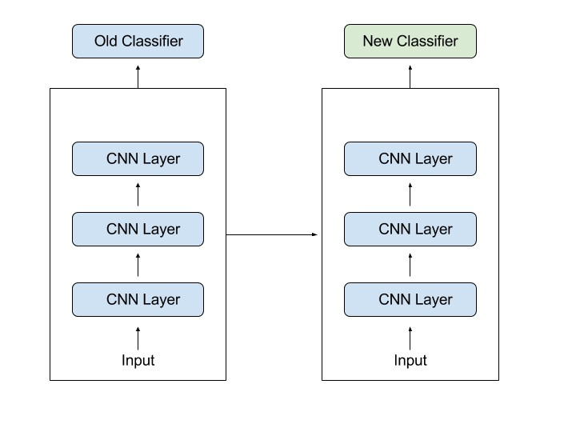

Figure

Figure 7 illustrates how transfer learning works. In computer vision, Neural Networks usually try to detect edges in earlier layers, shapes in middle layer and some task-specific features in the later layers. With transfer learning, using the early and middle layers and only retrain the latter layers.

The advantages of transfer learning:

* Transfer learning is an optimization that allows rapid progress or improved performance when modeling the second task.
* Transfer learning is related to problems such as multi-task learning and concept drift and is not exclusively an area of study for deep learning.
* Transfer learning helps to leverage the labeled data of the task it was initially trained on.

In this project, with transfer learning, pretraining a ConvNet on a very large dataset (e.g. ImageNet, which contains 1.2 million images with 1000 categories), and then using the ConvNet either as an initialization or a fixed feature extractor for the task of interest. The three major Transfer Learning scenarios look as follows:

1. ConvNet as fixed feature extractor
2. Fine-tuning the ConvNet
3. Pretrained models

Two popular models are used in this project:

1. VGGNet Model
2. ResNet Model

**3.1 VGGNet Model**

VGGNet are created by Visual Geometry Group of the University of Oxford with a 7.3% error rate at ILSVRC 2014. The main purpose of the project is to demonstrate that increasing network depth can improve the accuracy of the network to some extent. VGG Net have five models: A, A-LRN, B, C, D, and E. VGG-19 model is quite similar to AlexNet, have 5 large convolutional layers and three large fully connected layers. VGG Net use 3*3 sized filters.

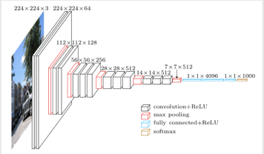

Figure

Figure 8 could tell how VGGNet works.

**3.2 ResNet Model**

ResNet was proposed in 2015 and won the first place in the ImageNet competition classification task, because it coexists "simple and practical". ResNet has been used, and Alpha Zero has also used ResNet, so it is obvious that ResNet is very useful.

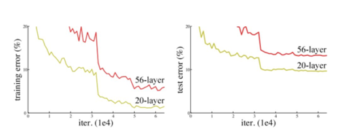

Figure

The core idea of ResNet is to introduce a so-called "identity shortcut connection" that skips one or more layers.

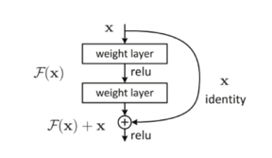

Figure

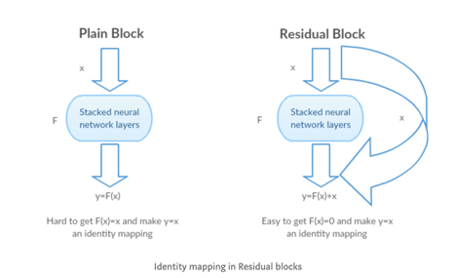

Figure

The ResNet network is referenced to the VGG19 network, modified based on it, and the residual unit is added through the identity shortcut connection, as shown in Figure 12. As can be seen from Figure 12, ResNet adds an identity shortcut connection between every two layers of the normal network, which forms a residual learning, in which the dotted line indicates that the number of feature maps has changed. Figure 12 shows the 34-layer ResNet, which can also build a deeper network as shown in Table 1. As can be seen from the table, for the 18-layer and 34-layer ResNet, the residual learning between the two layers is carried out.

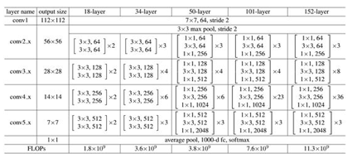

Table 1

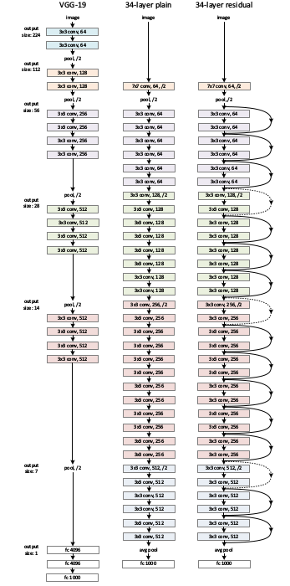

Figure

**4 Model Development Specification:**

**4.1 Platform**

The project run on AWS cloud computing platform. The main feature we use of AWS is Amazon Elastic Compute Cloud (Amazon EC2), Amazon EC2 P3 instances and AWS Deep Learning AMIs. The GPU we choose is p3.2xlarge with 61 GiB memory, 26 ECU and 8 vCPU.

**4.2 Environment**

The environment which the project run on, includes Tensorflow for Python3.6, Tensorflow-GPU, and TF-Slim.

**4.3 Strategy**

**4.3.1 More augmentation**

After the data augmentation at the data pre-processing stage, the data set is still unbalance with class Vascular lesions and class Dermatofibroma half the size of other classes. So more data augmentation is needed for the training process. Build data augmentation methods with tensorflow, setup augmentation flag to detect whether the input data need more augmentation.

**4.3.2 Pre-train weights and bias**

The pre-trained models, whether VGG19 of ResNet50 are both pre-trained with ImageNet dataset. So both models would have efficiently learned to extract features from images in order to perform well on the problem. The pre-trained weights would save us more training time and would get higher accuracy much quicker. It would be a good start point for the model training.

So first, customize the output layer of both VGG19 and ResNet50 models to output with seven classes. Then load the pre-trained weights and bias, and start the training.

**4.3.3 Training strategy**

For the training process, there are three stages. At the first training stage, train only the last fully connected layer which it’s weight is initialized, after getting a good start point, the second stage would be training the entire structure with learning rate of 1e-5, third stage will also train the entire structure but with less learning rate of 1e-6.

**4.3.4 Loss strategy**

For the loss strategy, it will be cross entropy loss between predict logits and real labels and cross entropy loss plus L2 regularizer. Regularization is a very important technique in machine learning to prevent overfitting. Mathematically speaking, it adds a regularization term in order to prevent the coefficients to fit so perfectly to overfit. The difference between the L1 and L2 is just that L2 is the sum of the square of the weights, while L1 is just the sum of the weights. L2 amounts to adding a penalty on the norm of the weights to the loss.

**5 Result and Discussion**

**5.1 Result**

The accuracy of model VGG19 after 10 epochs is 86.1% on the training set and 78.6% on the test set. 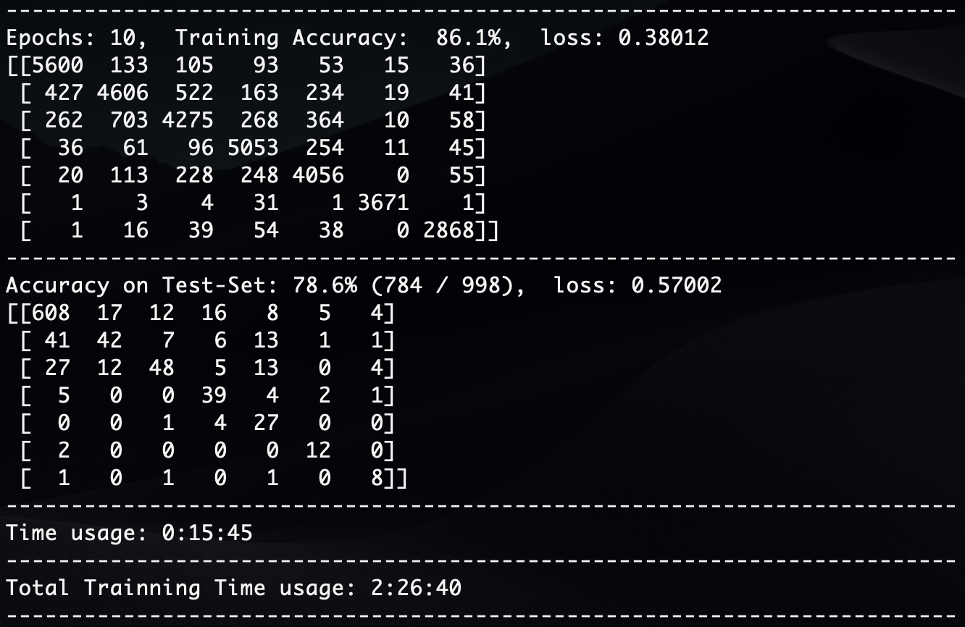

Figure

And after 20 epochs the VGG19 get an accuracy of 93.0% on training set and 82.2% on test set.

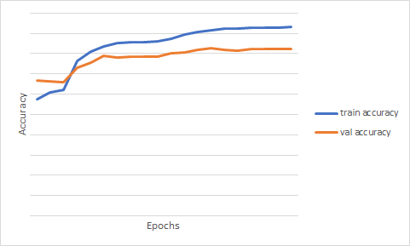

Figure

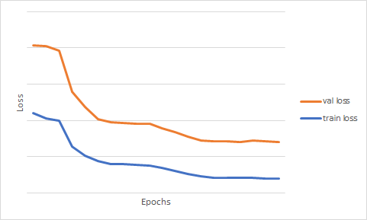

Figure

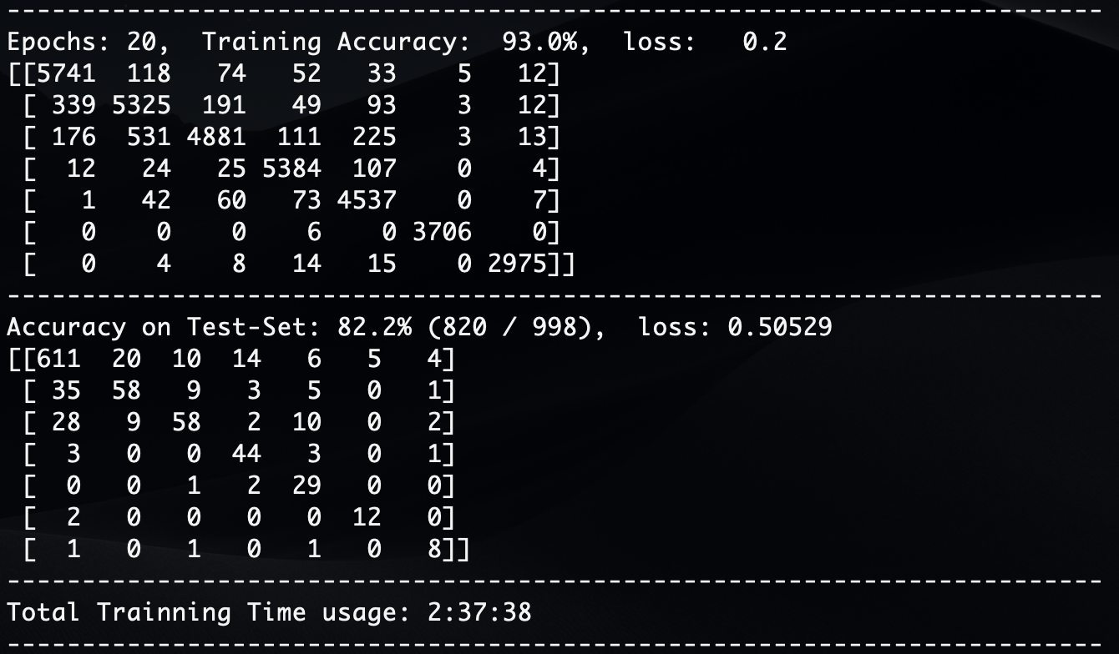

Figure

The accuracy of model ResNet50 after 15 epochs is 91.3% on the training set and 82.0% on the test set. 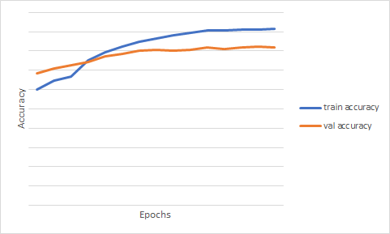

Figure

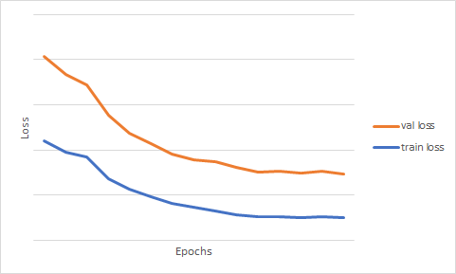

Figure

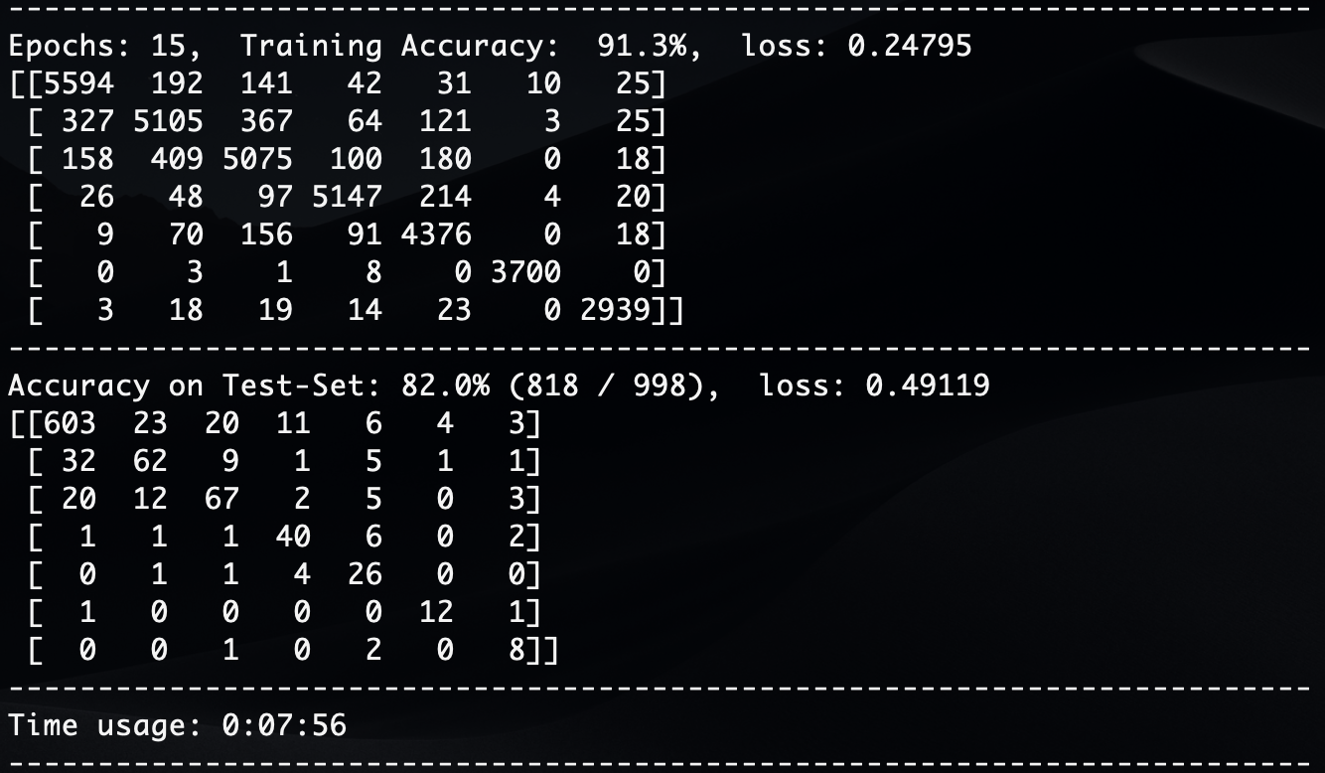

Figure

Because melanoma skin cancer causes 75% of skin cancer related deaths, we adjusted the threshold of the model so it would perform better on fatal skin cancer. Since melanoma begins in the melanocytes, which are the cells in the lowest layer of the epidermis. So we we adjusted the threshold of the model for class Melanocytic nevi Below are diagrams of accuracy on test set and the ROC curve.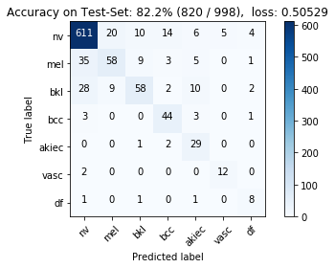

Figure

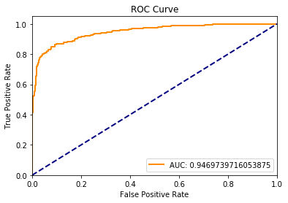

Figure

**5.2 Discussion**

* With the full structure of VGG19 and ResNet50 model, the performance on both train and test dataset are similar.
* This performance is very good, already ***beats all the performance result in Kaggle kernels and discussion board!***
* For ***VGG19 model***, the trend for the performance is tend to approach to a ***balanced*** level, it's very difficult for the model to capture further feature. As a result, if need to achieve better performance, more ***fine-tuning*** need to be done in the network of the model.
* For ***ResNet50 model***, the performance of test dataset is swing between 80% and 82%, and the loss value is being up-and-down around 0.5, as a result, a ***learning rate decay algorithm*** need to be inserted into the model training optimization.

**6. Future work**

To increase the performance of ResNet on the skin cancer dataset by doing fine-tuning, Batch Normalization and might be doing some research about the structure.

Batch Normalization is similar to normal data standardization. It is a way to unify scattered data and is a way to optimize neural networks. Data with uniform specifications can make machine learning easier to learn the rules of the data.

Also, we could try other different structure models to compare with VGG19 and ResNet50 in the future.

**Reference:**

* Simonyan, K., & Zisserman, A. (2014). Very deep convolutional networks for large-scale image recognition. arXiv preprint arXiv:1409.1556.
* He, K., Zhang, X., Ren, S., & Sun, J. (2016). Deep residual learning for image recognition. In Proceedings of the IEEE conference on computer vision and pattern recognition (pp. 770-778).
* Krizhevsky, A., Sutskever, I., & Hinton, G. E. (2012). Imagenet classification with deep convolutional neural networks. In Advances in neural information processing systems (pp. 1097-1105).
* Pan, S. J., & Yang, Q. (2010). A survey on transfer learning. IEEE Transactions on knowledge and data engineering, 22(10), 1345-1359.
* Deng, J., Dong, W., Socher, R., Li, L. J., Li, K., & Fei-Fei, L. (2009, June). Imagenet: A large-scale hierarchical image database. In Computer Vision and Pattern Recognition, 2009. CVPR 2009. IEEE Conference on (pp. 248-255). Ieee.
* Hernández-García, A., & König, P. (2018). Do deep nets really need weight decay and dropout?. arXiv preprint arXiv:1802.07042.
* Ioffe, S., & Szegedy, C. (2015). Batch normalization: Accelerating deep network training by reducing internal covariate shift. arXiv preprint arXiv:1502.03167.
* Díaz, G., & Romero, E. (2012). Micro‐structural tissue analysis for automatic histopathological image annotation. Microscopy research and technique, 75(3), 343-358.
* Cruz-Roa, A., Díaz, G., Romero, E., & González, F. A. (2011). Automatic annotation of histopathological images using a latent topic model based on non-negative matrix factorization. *Journal of pathology informatics*, *2*.
* Cruz-Roa, A., Caicedo, J. C., & González, F. A. (2011). Visual pattern mining in histology image collections using bag of features. *Artificial intelligence in medicine*, *52*(2), 91-106.
* Cruz-Roa, A., González, F., Galaro, J., Judkins, A. R., Ellison, D., Baccon, J., ... & Romero, E. (2012, October). A visual latent semantic approach for automatic analysis and interpretation of anaplastic medulloblastoma virtual slides. In *International Conference on Medical Image Computing and Computer-Assisted Intervention* (pp. 157-164). Springer, Berlin, Heidelberg.
* Pang, B., Zhang, Y., Chen, Q., Gao, Z., Peng, Q., & You, X. (2010, October). Cell nucleus segmentation in color histopathological imagery using convolutional networks. In *Pattern Recognition (CCPR), 2010 Chinese Conference on*(pp. 1-5). IEEE.
* He, L., Long, L. R., Antani, S., & Thoma, G. R. (2012). Histology image analysis for carcinoma detection and grading. *Computer methods and programs in biomedicine*, *107*(3), 538-556.
* Le, Q. V. (2013, May). Building high-level features using large scale unsupervised learning. In *Acoustics, Speech and Signal Processing (ICASSP), 2013 IEEE International Conference on*(pp. 8595-8598). IEEE.
* Raina, R., Battle, A., Lee, H., Packer, B., & Ng, A. Y. (2007, June). Self-taught learning: transfer learning from unlabeled data. In *Proceedings of the 24th international conference on Machine learning* (pp. 759-766). ACM.
* Bengio, Y., Courville, A., & Vincent, P. (2013). Representation learning: A review and new perspectives. *IEEE transactions on pattern analysis and machine intelligence*, *35*(8), 1798-1828.
* Montavon, G., Hasler, M., & Cosatto, E. (2009). A machine learning approach to classification of low resolution histological samples. *EPFL, Switzerland*.
* The American Cancer Society medical and editorial content team. (2016, May). What Is Melanoma Skin Cancer. Cancer.org
* Korotkov, K., & Garcia, R. (2012). Computerized analysis of pigmented skin lesions: a review. *Artificial intelligence in medicine*, *56*(2), 69-90.
* Lomas, A., Leonardi‐Bee, J., & Bath‐Hextall, F. (2012). A systematic review of worldwide incidence of nonmelanoma skin cancer. *British Journal of Dermatology*, *166*(5), 1069-1080.
* Ballerini, L., Fisher, R. B., Aldridge, B., & Rees, J. (2013). A color and texture based hierarchical K-NN approach to the classification of non-melanoma skin lesions. In *Color Medical Image Analysis* (pp. 63-86). Springer, Dordrecht.
* Leo, C. D., Bevilacqua, V., Ballerini, L., Fisher, R., Aldridge, B., & Rees, J. (2015). Hierarchical classification of ten skin lesion classes. In *Proc. Dundee Medical Image Analysis Workshop*.
* Kawahara, J., BenTaieb, A., & Hamarneh, G. (2016, April). Deep features to classify skin lesions. In *Biomedical Imaging (ISBI), 2016 IEEE 13th International Symposium on* (pp. 1397-1400). IEEE.
* Cruz-Roa, A. A., Ovalle, J. E. A., Madabhushi, A., & Osorio, F. A. G. (2013, September). A deep learning architecture for image representation, visual interpretability and automated basal-cell carcinoma cancer detection. In *International Conference on Medical Image Computing and Computer-Assisted Intervention* (pp. 403-410). Springer, Berlin, Heidelberg.
* Esteva, A., Kuprel, B., Novoa, R. A., Ko, J., Swetter, S. M., Blau, H. M., & Thrun, S. (2017). Dermatologist-level classification of skin cancer with deep neural networks. *Nature*, *542*(7639), 115.
* Mayo Clinic Staff ( 2018, Jan). Skin cancer. mayoclinic.org
* Vincent Fung. (2017, Jul). An Overview of ResNet and its Variants. Medium.
* Xie, S., Girshick, R., Dollár, P., Tu, Z., & He, K. (2017, July). Aggregated residual transformations for deep neural networks. In *Computer Vision and Pattern Recognition (CVPR), 2017 IEEE Conference on* (pp. 5987-5995). IEEE.
* He, K., Zhang, X., Ren, S., & Sun, J. (2016, October). Identity mappings in deep residual networks. In *European conference on computer vision* (pp. 630-645). Springer, Cham.
* He, K., Zhang, X., Ren, S., & Sun, J. (2016). Deep residual learning for image recognition. In *Proceedings of the IEEE conference on computer vision and pattern recognition* (pp. 770-778).